|  |  |
| --- | --- |
| **Reg. #** |  |
| **Marks** |  |

**EXPERIMENT # 2**

**Simulation of Three Phase uncontrolled AC/DC Conversion**

**Objective:**

To have a hands-on experience of three phase AC/DC power electronic conversion and verify the corresponding theory.

**Three Phase Rectification with Resistive Load**

The schematic diagram of the circuit to be used is shown in Fig. 1. The figure is divided into two portions; each portion will be implemented by a single Unitrain card.

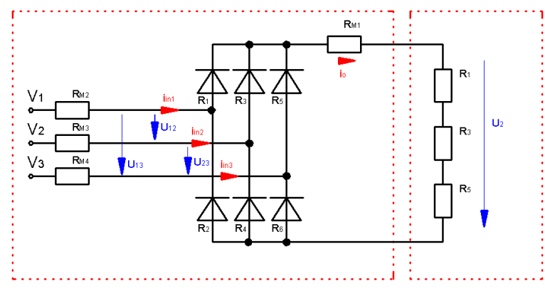

Figure. 1

Three phase uncontrolled rectifier is shown in figure 2 and three.

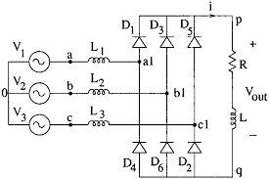

Figure 2

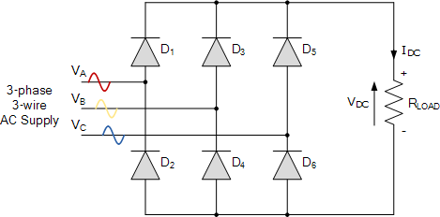

Figure 3

As before, assuming a phase rotation of Red-Yellow-Blue (VA – VB – VC) and the red phase (VA) starts at 0o. Each phase connects between a pair of diodes as shown. One diode of the conducting pair powers the positive (+) side of load, while the other diode powers the negative (-) side of load.

Diodes D1 D3 D2 and D4 form a bridge rectifier network between phases A and B, similarly diodes D3 D5 D4 and D6 between phases B and C and D5 D1 D6 and D2 between phases C and A.

Thus diodes D1 D3 and D5 feed the positive rail and depending on which one has a more positive voltage at its anode terminal conducts. Likewise, diodes D2 D4 and D6 feed the negative rail and whichever diode has a more negative voltage at its cathode terminal conducts.

Then we can see that for three-phase rectification, the diodes conduct in matching pairs giving a conduction pattern for the load current of: D1-2 D1-6 D3-6 D3-6 D3-4 D5-4 D5-2 and D1-2 as shown in figure 3. And simulation result is shown in figure 4.

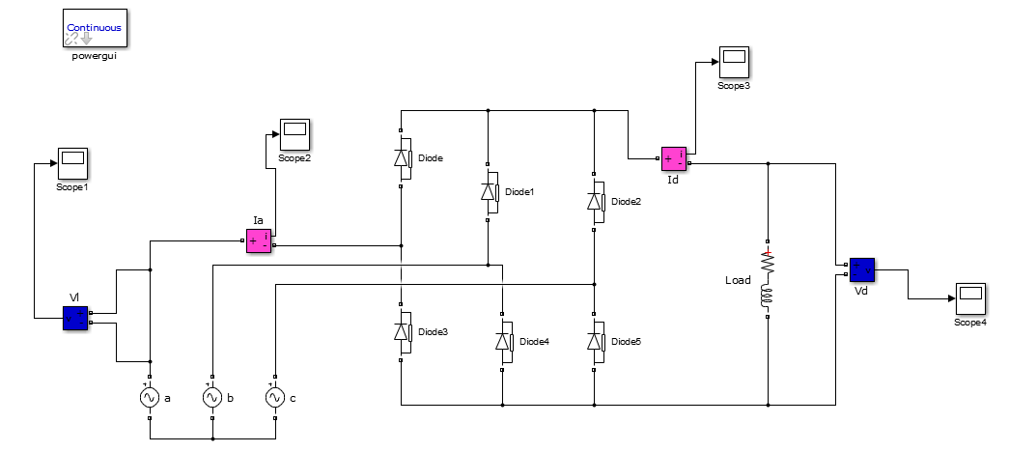

Figure 4

|  |
| --- |
| **Briefly mention your observations/learnings from this exercise below**  **___________________________________________________________________________________________________________________________________________________________________________________________________________________________________________________________________________________________________________** |